|  |  |
| --- | --- |
| **Ex no : 6** | **Create a map view using tableau** |
| **Date :** |

**AIM**

To create a map view using tableau for a selected data source.

**PROCEDURE**

Step 1: Import the super store data to tableau desktop from

C:\Program Files\Tableau\Tableau Prep Builder 2023.2\help\Samples\en_US

Step 2: Select the attributes for which the map view is needed (Location Attribute is mandatory)

Step 3: If live data is needed then connect to the tableau server using your tableau login

Step 4: In right side pane, double click on the geographical chart for map view of the data.

Step 5: Map view will be created and displayed in the workspace.

**OUTPUT**

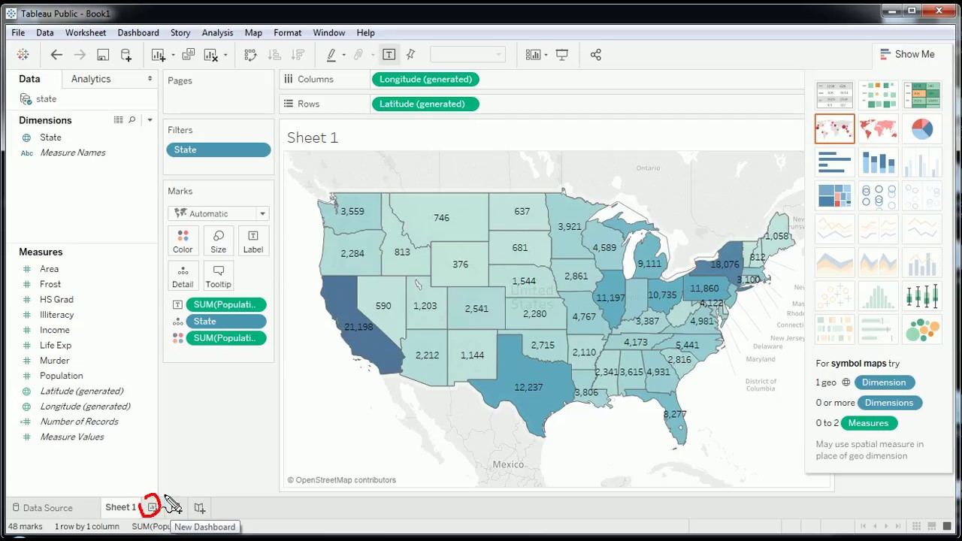

**RESULT**

Thus a map view using tableau for a selected data source has been built successfully.